LEAF HEALTH CHECK

Team ID: SWTID-2026-6208
Team Members:
Team Leader: PRIYANKA S, priyupriyanka2005@gmail.com
Team Member: GAYATHRI A, gayathri123annamalai@gmail.com
Team Member: AISWARYA M,gowtham07022000@gmail.com
Team Member: MOHANAPRIYA P,mohanapriya2817@gmail.com
Team Member: MONICA Y, prathapmonica372@gmail.com
Problem Context:
Plant diseases often appear on leaves as spots, discoloration, or texture changes. Identifying these diseases through manual inspection requires expert knowledge and time, and early symptoms are often missed. This can lead to plant damage and reduced crop productivity. Therefore, a simple and automated system is needed to quickly check leaf health and help in early detection of plant problems.
Objectives
1. Role Definition:
Define the role of the system in monitoring and analyzing plant leaf health.
2. Disease Detection:
Identify possible diseases or unhealthy conditions in plant leaves using images.
3. Early Identification:
Detect early symptoms such as spots, color changes, or damage on leaves.
4. User Support:
Assist farmers, gardeners, and researchers in checking plant health easily.
5. Time Efficiency:
Reduce the time and effort required for manual plant disease inspection.
6. Agricultural Improvement:
Support better plant care and help improve crop productivity.
Key Skills and Tools
1. Programming Language:
Python, Machine Learning / AI: Image Classification, Convolutional Neural Networks (CNN), Libraries and Frameworks: TensorFlow / Keras, OpenCV, NumPy, Pandas
Example installation:
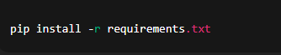
Run the application:
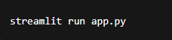
2. Development Tools:
Jupyter Notebook / Google Colab, Visual Studio Code
3. Image Processing Techniques:
Image preprocessing, Feature extraction, Image classification
4. Dataset Handling:
*Plant leaf image datasets, Data preprocessing and labeling
5. Web / Interface (Optional):
Flask or Streamlit for simple user interface.
Use Case Scenarios:
Scenario 1: Leaf Image Upload and Health Check
Users upload a plant leaf image through the Leaf Health Check web interface. The system processes the image by adjusting brightness, resizing it to the required size, and reducing noise for better analysis. The AI model then examines the leaf patterns, color variations, and spots to determine whether the leaf is healthy or affected by a disease. The system displays the result along with the prediction accuracy and health status.
Scenario 2: Disease Detection from Leaf Patterns
After the image is processed, the system analyzes visible symptoms such as yellow spots, brown patches, or irregular textures on the leaf. Using the trained machine learning model, the system compares these patterns with known disease features and predicts the possible disease affecting the leaf. This helps users understand the condition of the plant quickly and accurately.
Scenario 3: Health Status and Basic Care Suggestions
Based on the analysis of the leaf image, the system classifies the plant’s condition into levels such as Healthy, Mildly Affected, or Severely Affected. It then provides simple care suggestions such as improving watering practices, applying organic treatment, or removing infected leaves. These recommendations help users take quick action to maintain plant health and prevent further damage.
TASK INITIATION
Milestone 1: Dataset Collection:
Activity 1: Collect Leaf Images:
1. Identify different plant species for analysis.
2. Collect healthy and diseased leaf images.
3. Capture images using a mobile camera or download from public datasets.
4. Ensure images show clear symptoms such as spots, discoloration, or damage.
5. Organize images into folders (Healthy / Diseased).
6. Save the dataset for further processing.
Install Required Libraries
Create. env File
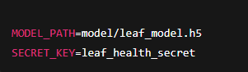
- Images show the collection of different plant leaf samples used for the project.
- Both healthy and diseased leaf images are collected for analysis.
- The images are captured using a mobile camera or downloaded from public datasets.
- All images are organized into separate folders for healthy and diseased leaves.
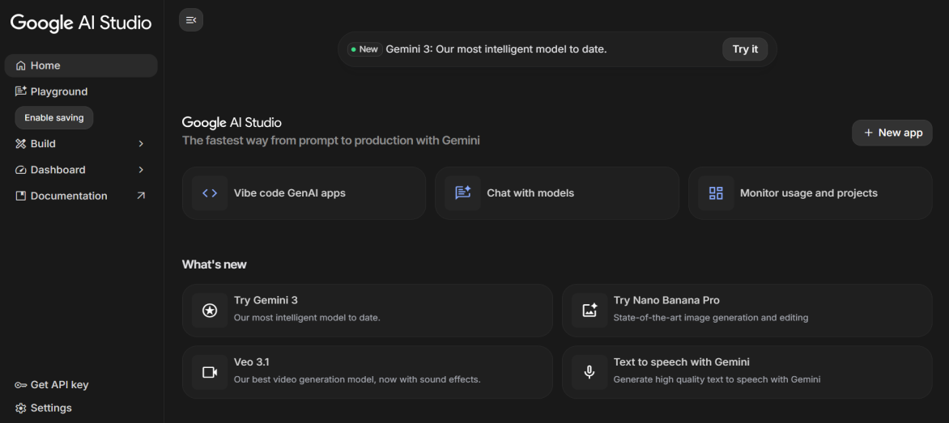
Activity: Open and Configure Google AI Studio
- Open the Google AI Studio platform in the web browser.
- Sign in using a Google account to access the dashboard.
- Explore the main interface including Home, Playground, Build, and Dashboard sections.
- Click on New App to start creating the Leaf Health Check application.
- Select the appropriate Gemini AI model for image analysis and AI processing.
- Enable the project settings and verify that the environment is ready for development.
- Generate or access the API key required for integrating AI features into the application.
- Save the project configuration for further development steps in the Leaf Health Check system.
Load Environment Variables
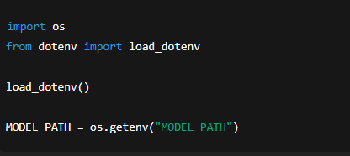
Test Model Loading
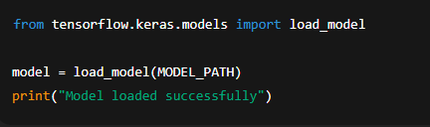
Test Image Preprocessing
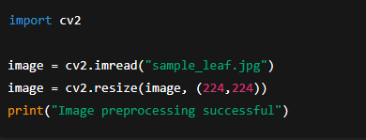Test Disease Prediction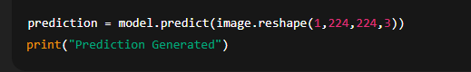
Milestone 2: Data Preparation:
Activity 1: Image Pre-processing:
1. Import the dataset into the development environment.
2. Resize images to a fixed resolution.
3. Remove noise and unwanted background from images.
4. Convert images into suitable formats for processing.
5. Label the images based on leaf condition.
6. Split the dataset into training and testing sets.

File Explorer Structure
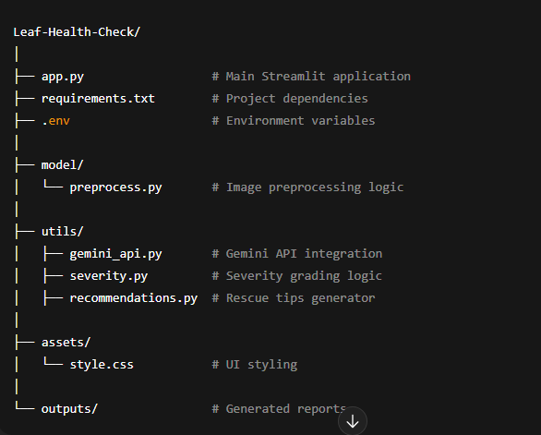
Activity 2: Creating the Project Folder Structure
- Create a main project folder named Leaf-Health-Check.
- Inside the main folder, create the main application file app.py for running the Streamlit interface.
- Create a requirements.txt file to store all required Python libraries and dependencies for the project.
- Add a .env file to store environment variables such as API keys and configuration details securely.
- Create a folder named model to store machine learning related files.
- Inside the model folder, create preprocess.py to handle image preprocessing tasks like resizing, brightness adjustment, and noise removal.
- Create a folder named utils for utility scripts used in the project.
- Inside the utils folder, create gemini_api.py to integrate the Gemini API for AI-based analysis.
- Add severity.py to calculate and classify the disease severity level of the leaf.
- Add recommendations.py to generate suggestions and recovery tips for plant health improvement.
- Create a folder named assets to store UI-related files.
- Inside the assets folder, create style.css to design and customize the application interface.
- Create an outputs folder to store generated reports and analysis results from the system.
Import Required Libraries
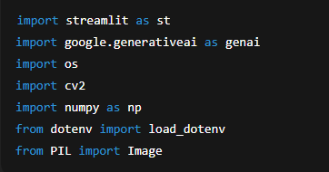
Initialize Environment and Gemini API
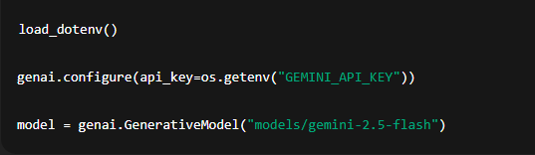
Image Upload Interface
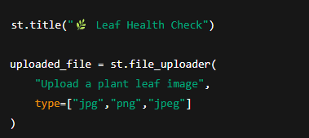
Image Processing
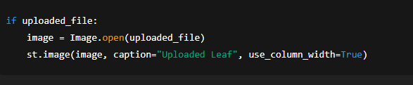
- The dataset is imported into the development environment for processing.
- Leaf images are resized to a fixed resolution for uniformity.
- Image preprocessing techniques are applied to remove noise and improve clarity.
- The images are labeled and split into training and testing datasets.
Gemini AI Diagnosis Request
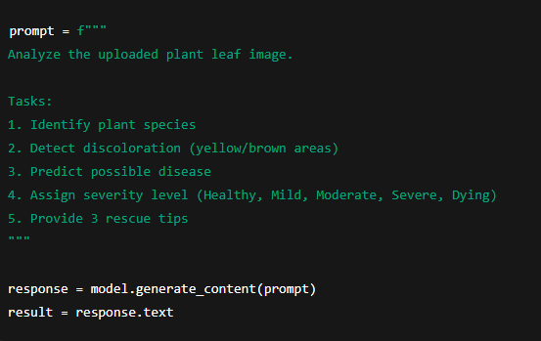
Display Result

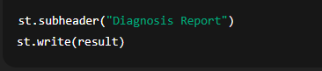
Severity Grading Logic
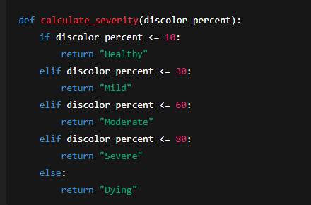
Generate Text Report
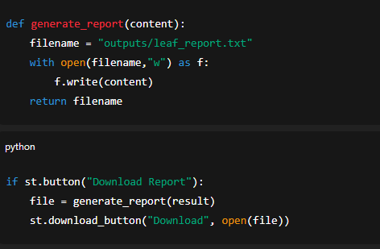
Clean AI Response
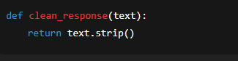
Unique File Generator
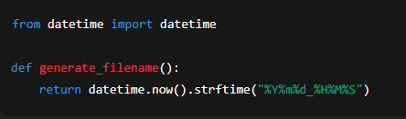
Milestone 3: Model Development:
Activity 1: Build Leaf Disease Detection Model:
1. Select a machine learning or deep learning approach.
2. Load the pre-processed dataset.
3. Train the model using the training dataset.
4. Configure model parameters and training settings.
5. Monitor training accuracy and loss values.
6. Save the trained model.
Image Validation Example
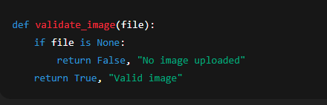
Main Application Structure
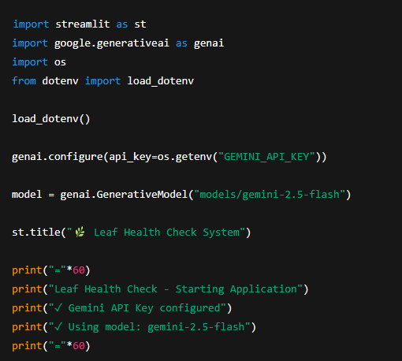
Activity 3: Import Required Libraries and Environment Setup
- This step shows the Python code used to import the required libraries for the Leaf Health Check application. The system uses Streamlit to build an interactive user interface where users can upload leaf images.
- The Google Generative AI library is imported to enable AI-based analysis and intelligent responses related to plant health.
- The code also imports OpenCV (cv2) and NumPy for image processing tasks such as resizing, noise removal, and feature extraction.
- The dotenv module is used to securely load API keys and environment variables from a configuration file. Additionally, the PIL (Python Imaging Library) is used for handling and displaying uploaded images in the application.
- By importing these libraries, the system prepares the development environment required for image processing, AI analysis, and building the interactive web interface for the Leaf Health Check system.

Generate Diagnosis from Image
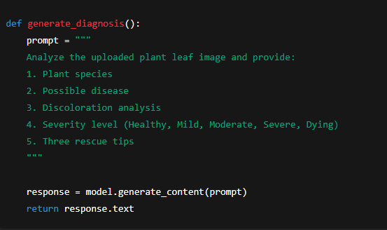
- The preprocessed dataset is used to train a machine learning model.
- A Convolutional Neural Network (CNN) is used for leaf disease detection.
- The model learns patterns such as spot discoloration and texture changes.
- Training progress is monitored using accuracy and loss values.

Display AI Response
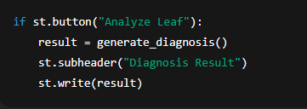
Report Generation
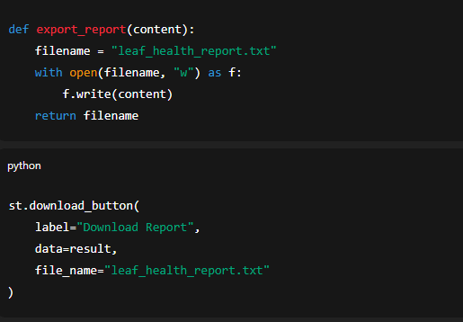
Error Handling and Response Formatting
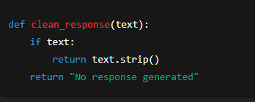
Milestone 4: Model Testing:
Activity 1: Evaluate Model Performance:
1. Load the trained model.
2. Test the model using the testing dataset.
3. Measure performance metrics such as accuracy.
4. Identify misclassified images.
5. Improve the model if necessary.
6. Finalize the optimized model.
Home Page Development
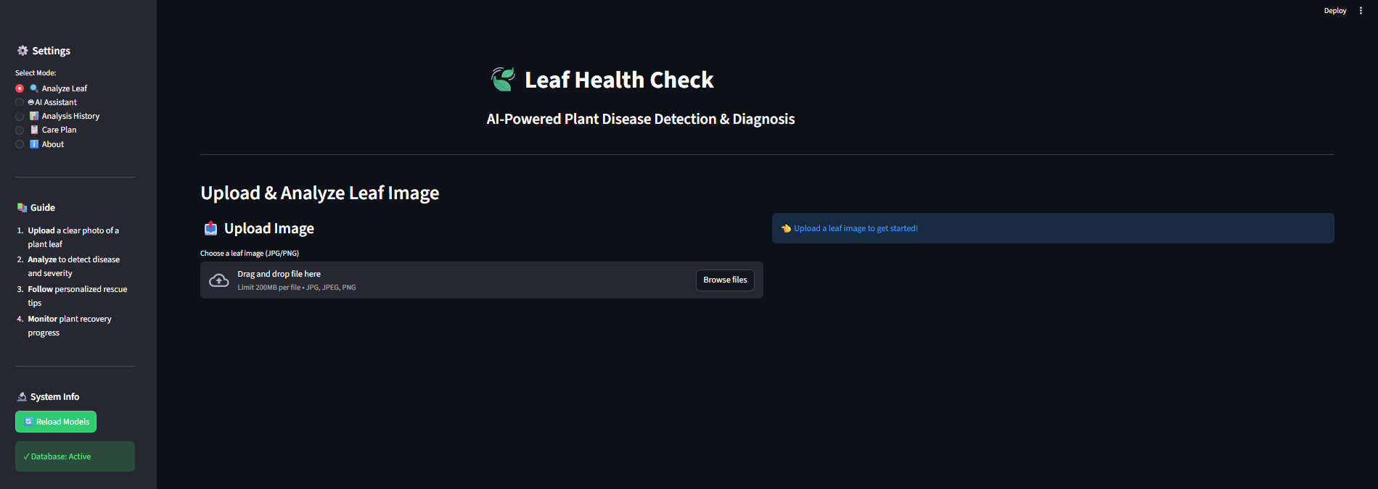
Leaf Analysis Page
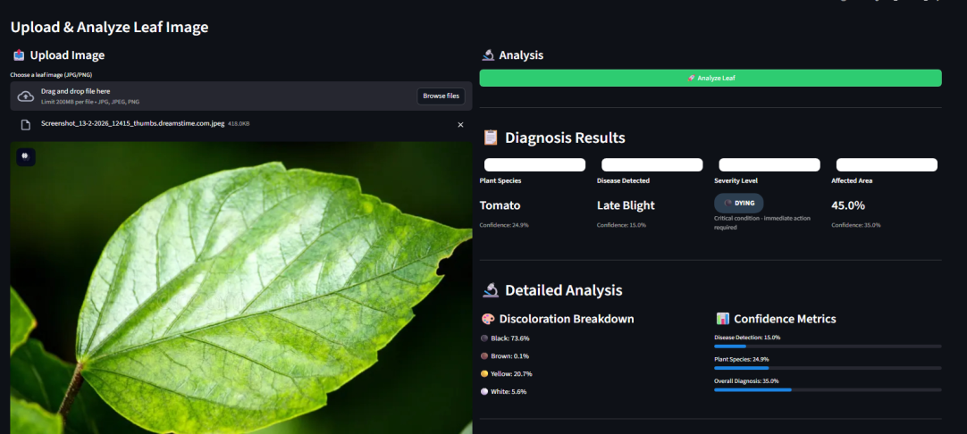
- The trained model is tested using the testing dataset.
- The system predicts whether a leaf is healthy or diseased.
- Model performance is evaluated using accuracy and other evaluation metrics.
- Misclassified images are analyzed to improve the model.

Rescue Recommendation Display
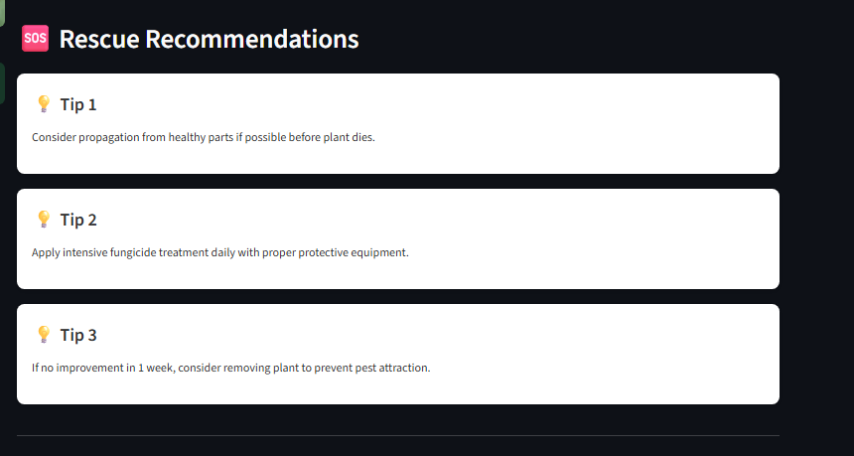
Result Export Option
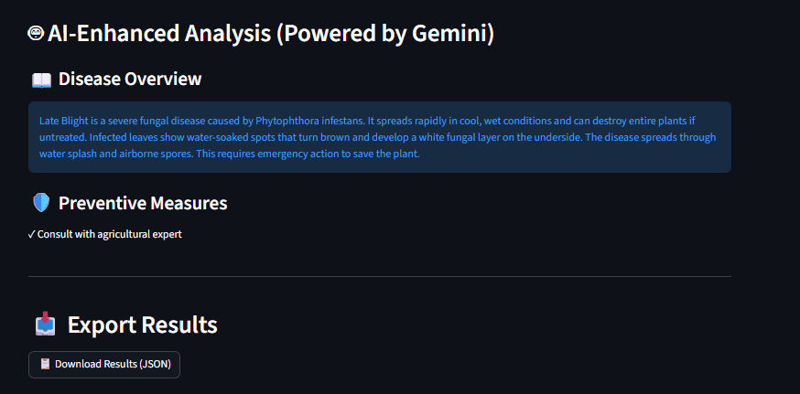
Milestone 5: Application Development:
Activity 1: Create Leaf Health Check Interface
1. Develop a simple user interface for image upload.
2. Allow users to upload leaf images.
3. Connect the interface with the trained model.
4. Process the uploaded image through the model.
5. Display the predicted result (Healthy or Diseased).
6. Show possible disease information if detected.
- A simple user interface is created for the Leaf Health Check system.
- Users can upload leaf images through the interface.
- The application processes the image and displays the prediction result.
- The system indicates whether the leaf is healthy or affected by disease.

Milestone 6: System Integration:
Activity 1: Integrate Model with Application:
1. Deploy the trained model into the application backend.
2. Connect the prediction function with the user interface.
3. Ensure real-time image analysis works correctly.
4. Handle errors during image upload or processing.
5. Test the complete workflow from upload to prediction.
- The trained machine learning model is integrated with the application.
- The system connects the image upload interface with the prediction model.
- The uploaded image is processed in real time to generate results.

Milestone 7: Testing and Validation:
Activity 1: Test the Application
1. Upload multiple leaf images for testing.
2. Verify prediction results.
3. Check system response time and accuracy.
4. Identify and fix bugs or errors.
5. Validate system performance with different plant images.
- The application is tested using different leaf images.
- Prediction results are verified to ensure accuracy.
- The system is checked for response time and error handling.

Milestone 8: Documentation
Activity 1: Prepare Project Documentation:
1. Document the project objective and problem statement.
2. Describe dataset collection and preprocessing steps.
3. Explain the model development and testing process.
4. Include system architecture and workflow diagrams.
5. Record results and evaluation metrics.
6. Finalize the project report.
- Project documentation is prepared including objectives, dataset details, and methodology.
- System workflow diagrams and model results are included in the report.
- The final report explains the complete development and testing process.

Milestone 9: Deployment:
Activity 1: Deploy the Leaf Health Check System
1. Deploy the application on a local or cloud server.
2. Ensure users can access the application easily.
3. Monitor system performance.
4. Provide instructions for using the application.
5. Maintain and update the system when required.
- The Leaf Health Check system is deployed on a local or cloud server.
- Users can access the application to upload leaf images and check plant health.
- The system is monitored and maintained for smooth operation.

Conclusion:
The Leaf Health Check project helps detect plant leaf diseases using image processing and machine learning. The system analyzes leaf images to identify whether a leaf is healthy or diseased. It reduces the need for manual inspection and saves time for farmers and gardeners. Overall, this project supports early disease detection and helps improve plant care and crop productivity.

